**Dashboard Design**

|  |  |
| --- | --- |
| Date | 24 June 2025 |
| Project Name | Power BI Inflation Analysis – Journeying Through Global Economic Terrain |
| Maximum Marks | 5 Marks |

Creating an effective dashboard involves thoughtful design to ensure that the presented information is clear, relevant, and easily understandable for the intended audience. Here are some key principles and best practices followed in designing the final dashboard.

**Dashboard 1: Global Inflation Trends Through Time and Regions**

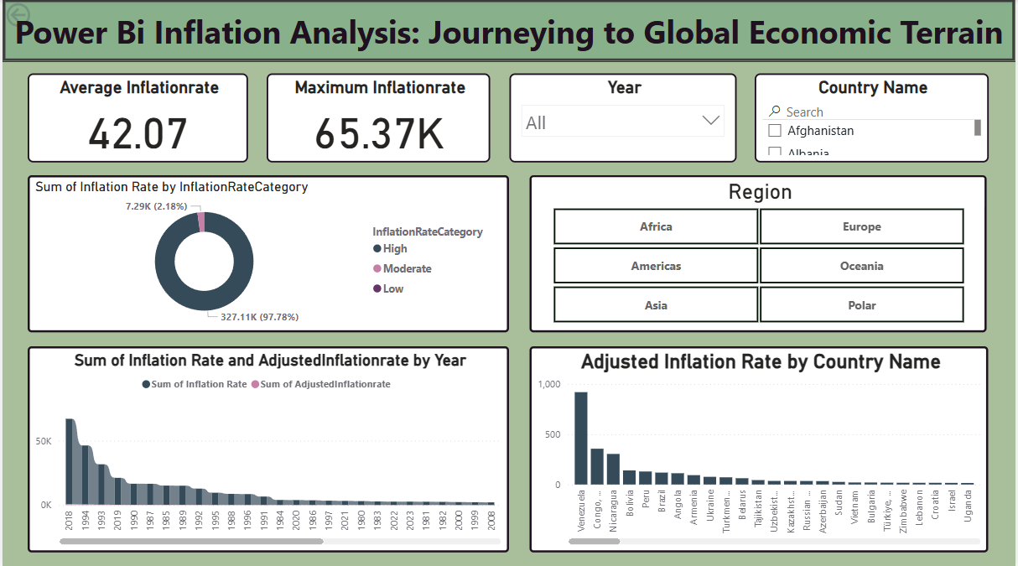

* **Average Inflation Rate: The average inflation rate globally is 42.07, derived from historical CPI data across countries from 1960 to 2023.**
* **Maximum Inflation Rate: The highest recorded inflation rate in the dataset is 65.37K, attributed to countries experiencing hyperinflation episodes such as Venezuela and Zimbabwe.**
* **Category-Wise Breakdown: A donut chart categorizes inflation rates into High, Moderate, and Low, showing that a majority of countries fall under the moderate inflation bracket, indicating a manageable economic environment globally.**
* **Time-Based Trends: A column chart shows the sum of inflation rate and adjusted inflation rate over years, highlighting economic crises such as the early 1980s inflation spike, 2008 global recession, and COVID-19 impact in recent years.**
* **Country-Wise Comparison: A bar chart ranks countries by adjusted inflation rate, revealing that Venezuela, Congo, Nicaragua, and Bolivia have had persistently high inflation in the modern period.**
* **Interactive Filtering: Users can interactively filter by Year, Country, and Region (Africa, Asia, Europe, Americas, Oceania, Polar) to examine localized inflation patterns and compare between countries or continents.**
* **User Interface and Layout: The dashboard adopts a clean layout with bold KPIs on the top, category distribution visuals in the center, and trend/deviation charts at the bottom. Buttons and slicers make the experience dynamic and insightful for business users, students, and policymakers.**